THE PARISH of HADZOR with ODDINGLEY and TIBBERTON

St James, Oddingley  www.oddingleychurch.org | Notices  Week beginning  Sunday 12th January 2025  First Sunday of Epiphany  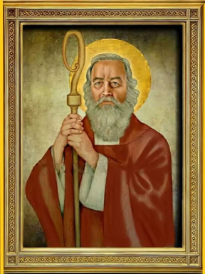 |   St Peter-ad-Vincula, Tibberton  www.tibbertonchurch.org
St Hilary of Poitiers is celebrated tomorrow, 13th January

Upcoming Services:

Sunday 19th January Tibberton Informal Service at 10.30am (R Barrett)
Second Sunday of Epiphany
Oddingley Evensong at 10.30am (W Sumner)

Readings: Canticle Psalm 36
Old Testament Isaiah 62:1-5
New Testament 1 Corinthians 12:1-11
Gospel John 2:1-11

Events:

Wednesday 15th January Bible Study & Fellowship Group, 10.00am at Foxley Barn, Lower Crowle. This session will involve a discussion to decide which course to follow next. All are welcome; please note the new start time.

Saturday 18th January The Tibberton Drop-In, 10.30am-12.00pm at The Old Vicarage, Plough Road, by kind invitation of Andrew and Elizabeth Morton. All are welcome for tea, coffee and friendly conversation.

Thursday 6th February Monthly Night Out, from 8.00pm at The Bridge, Tibberton. Join us for our informal monthly catch-up.

.

Calendar:

DATE | FUNCTION | VENUE | TIME
January
12th Sunday | Matins | Oddingley Church | 9.00am
15th Wednesday | Study & Fellowship Group | Foxley Barn, Lower Crowle | 10.00am
18th Saturday | The Tibberton Drop-In | The Old Vicarage, Plough Rd | 10.30am-12.00pm
19th Sunday | Informal Service | Tibberton Church | 10.30am
 | Evensong | Oddingley Church | 4.00pm
28th Tuesday | Study & Fellowship Group | Ruslin, Tibberton | 10.00am
26th Sunday | Holy Communion | Tibberton Church | 10.30am
February
2nd Sunday | Holy Communion | Tibberton Church | 10.30am
8th Saturday | The Tibberton Drop-In | Broadfield Cottage | 10.30am-12.00pm
9th Sunday | Matins | Oddingley Church | 9.00am
12th Wednesday | Study & Fellowship Group | Wentworth House, Himbleton | 10.00am
16th Sunday | Informal Service | Tibberton Church | 10.30am
 | Evensong | Oddingley Church | 4.00pm
23rd Sunday | Holy Communion | Oddingley Church | 9.00am
25th Tuesday | Study & Fellowship Group | Foxley Barn, Lower Crowle | 10.00am

Collect for the First Sunday of Epiphany:

O Lord, we beseech thee mercifully to receive the prayers of thy people which call upon thee;
and grant that they may both perceive and know what things they ought to do,
and also may have grace and power faithfully to fulfil the same;
through Jesus Christ our Lord.
Amen.

