THE PARISH of HADZOR with ODDINGLEY and TIBBERTON

St James, Oddingley  www.oddingleychurch.org | Notices  Week beginning  Sunday 1st June 2025  Sunday after Ascension Day  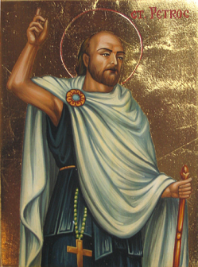 | 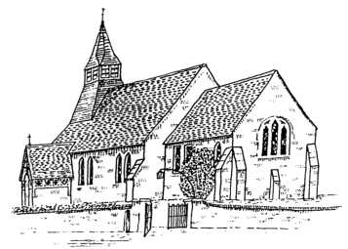  St Peter-ad-Vincula, Tibberton  www.tibbertonchurch.org
St Petroc, Abbot of Padstow, is celebrated this Wednesday 4th June.

Upcoming Services:

Sunday 8th June Oddingley Matins at 9.00am
Whitsun (Pentecost)

Readings: Canticle Psalm 104
New Testament Acts 2:1-21
Romans 8:14-17
Gospel John 14:8-17

Events:

Tuesday 3rd June Annual Parochial Church Meeting, 7.30pm at Tibberton Village Hall. Church officers for the next year will be elected and the Annual Report and Accounts may be discussed. All members of the electoral roll are entitled to vote, and all are welcome to attend.

Thursday 5th June Monthly Night Out, from 8.00pm at The Pear Tree Inn (please note the change of venue this month). Please drop by for our informal monthly catch-up – you’ll find us outside if it’s good weather or else in the seating area for Lilian’s Tea Room.

Saturday 14th June Bowbrook Prayer Time, from 10.00am at Himbleton Church. Join us at any point during this hour of prayer.

Calendar:

DATE | FUNCTION | VENUE | TIME
June
1st Sunday | Holy Communion | Tibberton Church | 10.30am
3rd Tuesday | Annual Parochial Church Meeting | Tibberton (new) Village Hall | 7.30pm
5th Thursday | Monthly Night Out | The Pear Tree Inn | From 8.00pm
8th Sunday | Matins | Oddingley Church | 9.00am
14th Saturday | Bowbrook Prayer Time | Himbleton Church | 10.00-11.00am
14th Saturday | The Tibberton Drop-In | Gordons Farm | 10.30am-12.00pm
15th Sunday | Informal Service | Tibberton Church | 10.30am
15th Sunday | Evensong | Oddingley Church | 6.30pm
22nd Sunday | Holy Communion | Tibberton Church | 10.30am
28th Saturday | Ordination of Priests | Worcester Cathedral | 2.00pm
29th Sunday | Holy Communion | Stock & Bradley Church | 10.00am
29th Sunday | Ordination of Deacons | Worcester Cathedral | 10.30am

Collect for the Sunday after Ascension Day:

O God the King of glory, who hast exalted thine only Son Jesus Christ with great triumph unto thy kingdom in heaven: We beseech thee, leave us not comfortless; but send to us thine Holy Ghost to comfort us, and exalt us unto the same place whither our Saviour Christ is gone before, who liveth and reigneth with thee and the Holy Ghost, one God, world without end.
Amen.

