THE PARISH of HADZOR with ODDINGLEY and TIBBERTON

St James, Oddingley  www.oddingleychurch.org | Notices  Week beginning  Sunday 20th April 2025  Easter Sunday  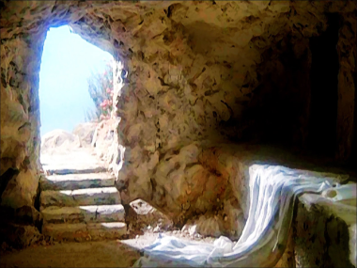 | 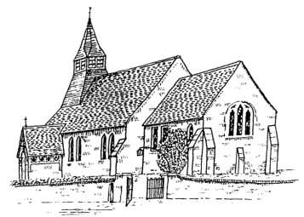  St Peter-ad-Vincula, Tibberton  www.tibbertonchurch.org
He is Risen: Happy Easter!

Upcoming Services:

Sunday 27th April Tibberton Holy Communion at 10.30am (R Sandland)
Second Sunday of Easter

Readings: Canticle Psalm 118:14-end
New Testament Acts 5:27-32
Revelation 1:4-8
Gospel John 20:19-end

Events:

Thursday 1st May Monthly Night Out, from 8.00pm at The Bridge Inn, Tibberton. All are welcome to join us for this informal monthly catch-up

Saturday 10th May The Tibberton Drop-In, 10.30am-12.00pm at Daniels Farm, Church Lane. Please do drop in for tea, coffee and friendly conversation.

Calendar:

DATE | FUNCTION | VENUE | TIME
April
20th Sunday | Holy Communion | Oddingley Church | 9.00am
27th Sunday | Holy Communion | Tibberton Church | 10.30am
May
1st Thursday | Monthly Night Out | The Bridge Inn, Tibberton | From 8.00pm
4th Sunday | Holy Communion | Tibberton Church | 10.30am
10th Saturday | The Tibberton Drop-In | Daniels Farm, Church Lane | 10.30am-12.00pm
11th Sunday | Matins | Oddingley Church | 9.00am

Collect for Easter Sunday:

Almighty God, who through thine only-begotten Son Jesus Christ hast overcome death,
and opened unto us the gate of everlasting life:
We humbly beseech thee,
that as by thy special grace preventing us thou dost put into our minds good desires,
so by thy continual help we may bring the same to good effect;
through Jesus Christ our Lord,
who liveth and reigneth with thee and the Holy Ghost,
ever one God, world without end.
Amen.

