THE PARISH of HADZOR with ODDINGLEY and TIBBERTON

St James, Oddingley  www.oddingleychurch.org | Notices  Week beginning  Monday 19th January 2026  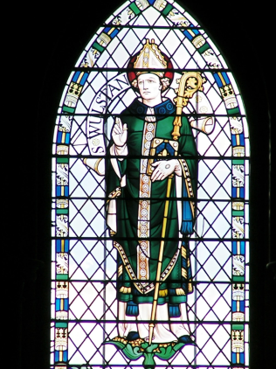 | 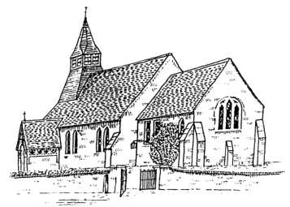  St Peter-ad-Vincula, Tibberton  www.tibbertonchurch.org
Today we celebrate the feast of St Wulfstan of Worcester, famous for being one of the few high-ranking English churchmen to keep his position after the Norman Conquest. At his death in 1095 he was the only English-born bishop left in England. We owe a huge debt to Wulfstan for putting Worcester Cathedral firmly on the map.

Upcoming Services:

Sunday 25th January Oddingley Holy Communion at 9.00am (R Sandland)
Third Sunday after the Epiphany

Readings: Canticle Psalm 27
Old Testament Isaiah 9:1-4
New Testament 1 Corinthians 1:10-18
Gospel Matthew 4:12-23

Events:

Monday 19th January Special Communion Service, 5.30pm at Worcester Cathedral. Dick Johnson has been given the honour of the annual award of the Cross of St Wulfstan, presented at this service. We all wish him well as he prepares to move to Japan. The Bishop will be preaching.

Calendar:

DATE | FUNCTION | VENUE | TIME
January
19th Monday | Special Communion Service | Worcester Cathedral | 5.30pm
25th Sunday | Holy Communion | Oddingley Church | 9.00am
February
1st Sunday | Holy Communion | Tibberton Church | 10.30am
7th Saturday | The Tibberton Drop-In | The Old Forge, Plough Road | 10.30am-12.00pm

Collect for the Second Sunday after the Epiphany:

Almighty and everlasting God, who dost govern all things in heaven and earth: Mercifully hear the supplications of thy people, and grant us thy peace all the days of our life; through Jesus Christ our Lord. Amen.

