THE PARISH of HADZOR with ODDINGLEY and TIBBERTON

St James, Oddingley  www.oddingleychurch.org | Notices  Week beginning  Monday 8th June 2026  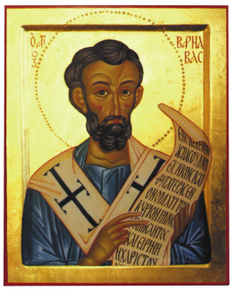 | 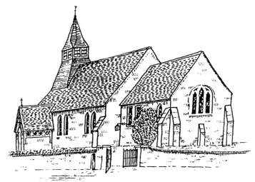  St Peter-ad-Vincula, Tibberton  www.tibbertonchurch.org
St Barnabas the Apostle is celebrated on 11th June.

Upcoming Services:

Sunday 14th June Oddingley Matins at 9.00am (P Honniball)
Second Sunday after Trinity

Readings: Canticle Psalm 100
Old Testament Exodus 19:2-8
New Testament Romans 5:1-8
Gospel Matthew 9:35-10:8

Events:

Saturday 13th June Bowbrook Prayer Time, 9.30-10.30am at Himbleton Church. Drop in for quiet prayer, and stay for as long as you’d like to.

The Tibberton Drop-In, 10.30am-12.00pm at 8, Vardroe Way, off Hawthorn Rise, Tibberton. By kind invitation of Christina and Geoff Robinson. Please join us for Coffee and friendly conversation.

Saturday 27th June Ordination of Priests, 2.00pm at Worcester Cathedral. Our own Tobias will be one of those priested. Everyone is welcome to attend.

Sunday 28th June Ordination of Deacons, 10.30am at Worcester Cathedral. All are welcome to attend.
Calendar:

DATE | FUNCTION | VENUE | TIME
June
13th Saturday | The Tibberton Drop-In | 8, Vardroe Way | 10.30am-12.00pm
14th Sunday | Matins | Oddingley Church | 9.00am
21st Sunday | Morning Service | Tibberton Church | 10.30am
21st Sunday | Evensong | Oddingley Church | 6.00pm
27th Saturday | Ordination of Priests | Worcester Cathedral | 2.00pm
28th Sunday | Holy Communion | Oddingley Church | 9.00am
 | Ordination of Deacons | Worcester Cathedral | 10.30am
July
2nd Thursday | Monthly Night Out | The Plough, Tibberton | From 7.45pm

Collect the First Sunday after Trinity:

O God, the strength of all them that put their trust in thee, mercifully accept our prayers; and because through the weakness of our mortal nature we can do no good thing without thee, grant us the help of thy grace, that in keeping of thy commandments we may please thee, both in will and deed; through Jesus Christ our Lord. Amen.

