THE PARISH of HADZOR with ODDINGLEY and TIBBERTON

St James, Oddingley  www.oddingleychurch.org | Notices  Week beginning  Monday 17th November 2025  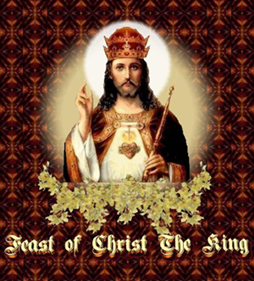 |   St Peter-ad-Vincula, Tibberton  www.tibbertonchurch.org
This Sunday we celebrate Christ the King.

Upcoming Services:

Sunday 23rd November Oddingley Holy Communion at 9.00am (R Sandland)
Christ the King

Readings: Canticle Psalm 46
Old Testament Jeremiah 23:1-6
New Testament Colossians 1:11-20
Gospel Luke 21:1-4

Events:

Thursday 4th December Monthly Night Out, from 8.00pm at Speed the Plough, Tibberton.

Saturday 13th December Bowbrook Prayer Time, 9.30-10.30am at Himbleton Church.

There is no December Tibberton drop-in but this will resume in January.

Calendar:

DATE | FUNCTION | VENUE | TIME
November
23rd Sunday | Holy Communion | Oddingley Church | 9.00am
30th Sunday | Group Holy Communion | Tibberton Church | 10.00am
December
4th Thursday | Monthly Night Out | Speed the Plough | From 7.45pm
7th Sunday | Holy Communion | Tibberton Church | 10.30am
13th Saturday | Bowbrook Prayer Time | Himbleton Church | 9.30-10.30am

Collect for the Twenty-Second Sunday after Trinity:

Lord, we beseech thee to keep thy household the Church in continual godliness; that through thy protection it may be free from all adversities, and devoutly given to serve thee in good works, to the glory of thy name; through Jesus Christ our Lord. Amen.

