THE PARISH of HADZOR with ODDINGLEY and TIBBERTON

  St James, Oddingley  www.oddingleychurch.org | Notices  Week beginning  Monday 28th September 2026  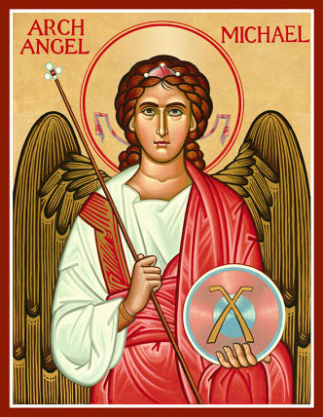 |   St Peter-ad-Vincula, Tibberton  www.tibbertonchurch.org
St Michael and All Angels are celebrated tomorrow, 29th September.

Upcoming Services:

Sunday 4th October Tibberton Harvest Family Service at 10.30am
St Francis’ Day Any donations of produce are most welcome.
Readings: Canticle Psalm 80
Old Testament Isaiah 5:1-7
New Testament Philippians 3:4-14
Gospel Matthew 21:33-end

Events:

Thursday 1st October Monthly Night Out, from 7.45pm at The Plough, Tibberton. All are welcome for refreshment and good company.

Saturday 10th October Bowbrook Benefice Prayer Time, 9.30-10.30am at Himbleton Church. Drop in for quiet prayer and stay as long as you like.

Saturday 17th October Monthly Drop-In, 10.30am-12.00pm at Ruslin, Plough Road, by kind invitation of Richard and Justine Barrett. All are welcome for tea, coffee and friendly conversation.

Details of the Bowbrook Benefice Study and Fellowship Group for October will be in next week’s Notices when the Bowbrook News has been published.
Calendar:

I have not yet received the October service rota, so the services below may be subject to change.

DATE | FUNCTION | VENUE | TIME
October
1st Thursday | Monthly Night Out | The Plough, Tibberton | From 7.45pm
4th Sunday | Harvest Family Service | Tibberton Church | 10.30am
10th Saturday | Bowbrook Prayer Time | Himbleton Church | 9.30-10.30am
11th Sunday | Matins | Oddingley Church | 9.00am
17th Saturday | Monthly Drop-In | Ruslin, Plough Road | 10.30am-12.00pm
18th Sunday | Morning Service | Tibberton Church | 10.30am
18th Sunday | Harvest Evensong | Oddingley Church | 6.00pm
25th Sunday | Holy Communion | Oddingley Church | 9.00am

Collect for St Michael and All Angels:

O everlasting God, who hast ordained and constituted the services of Angels and men in a wonderful order: Mercifully grant that, as thy holy Angels alway do thee service in heaven, so by thy appointment they may succour and defend us on earth; through Jesus Christ our Lord. Amen.

